

**Project Report**

**ON**

**“MMC Blog and Notice System”**

**Submitted To**

Department of Computer Science and Application

Mechi Multiple Campus

In partial fulfillment of the requirements of Project III (CACS 452)

Of

Bachelors of Computer Application

**Submitted By**

Ashish Neupane

Pramisa Poudel



**Tribhuvan University**

**Faculty of Humanities and Social Sciences**

**Mechi Multiple Campus**

**Supervisor’s Recommendation**

A project entitled “MMC Blog and Notice System” has been submitted by Ashish Neupane and Pramisa Poudel in the partial fulfillment of the requirements for the degree of Bachelor in Computer Application (BCA) of Tribhuvan University.

……………………………..

**Supervisor**

Raju Poudel

Mechi Multiple Campus

Bhadrapur



**Tribhuvan University**

**Faculty of Humanities and Social Sciences**

Mechi Multiple Campus

**Letter of Approval**

This is to certify that this project report prepared by **Mrs. Pramisa Poudel and Mr. Ashish Neupane** in partial fulfillment of the requirements for the degree of Bachelor of Computer Application has been evaluated. In our opinion, it is excellent, and is satisfactory in the scope and quality as an internship report for the required degree.

|  |  |
| --- | --- |
| **________________**  Raju Poudel  **Supervisor**  Lecturer, BCA | **________________**  Krishna Prasad Acharya  **Director**  Lecturer, BCA |
| **________________**  Sunil Sharma  **Vice Director**  Lecturer, BCA | **________________**  **External Examiner** |

# ABSTRACT

The MMC Blog and Notice System for colleges that can be accessed by the organization and students. Teachers and other staffs can be accessed information with login. MMC Blog and Notice System helps to get notices regarding public holidays, vacations, exam routines, leaves, results, any extracurricular activities and ongoing activities which are conducted in our college. Students can get notices easily whenever they needed.

MMC Blog and Notice System is such a system that provides services for an educational institution to make efficient and effective access of notices related to institution. Easy Notice Management, Easy Exam Routine and Result Process.

In a MMC Blog and Notice System, we can post and view any information related to the college. The system also allows general users to get information through the android app. The information is made using the latest technologies and helps to make decision making a lot faster, more effective, and easier than ever before. Also helps to improve the overall quality of education of the institution.

**ACKNOWLEDGEMENT**

Foremost, we would like to express our sincere thanks of gratitude to our supervisor, Sir. Raju Poudel for his continuous support and help in the internship work. We cannot thank him enough for all his patience, motivation, and immense knowledge. His guidance helped us all the time with the project.

We would also like to thank our Program Director Sir. Krishna Prasad Acharya and Deputy-Director Sir. Sunil Sharma for the role they played to make it possible for selected IT students of Mechi Multiple Campus to work as an intern for campus’ Department of IT. Without him, we would miss such a life-changing experience and a golden chance to grow our knowledge. We appreciate all the technical support and motivation given by BCA program Mechi Multiple Campus.

We would like to express our gratitude to Tribhuvan University for providing us a great opportunity of collecting. Lastly, we want to thank our parents and friends and all known unknown individuals who helped us in various way during our project period. With this project, we got a chance to collect real world work experience as a software developer. we are thankful to them for all their support, helps guidance, motivation, and corrections.

We have tried to mention and give credit to everyone who helped us in this project, along with the sources from where we collected the required data and information which supported this project. Yet, there may be some unintended errors and some sources or individuals may have been missed to mention. We shall feel obligated if they are brought to our notice.

2022/05/24

Ashish Neupane

Pramisa Poudel

Contents

**ABSTRACT 4**

**Chapter 1 Introduction 8**

**1.1 Introduction to MMC Blog and Notice System 8**

**1.2 Problem Statement 8**

**1.3 Objectives 9**

**1.4 Scope and Limitation 9**

**1.5 Development Methodology 10**

**1.6 Member Roles 11**

**1.7 Report Organization 11**

**Chapter 2 Background Study and Literature Review 12**

**2.1 Background Study 12**

**2.2 Literature Review 13**

**Chapter 3 System Analysis and Design 14**

**3.1 System Analysis 14**

**3.1.1 Requirement Analysis 14**

**3.1.2 Feasibility Study 14**

**i) Technical Feasibility Study 14**

**ii)** **Operational Feasibility Study** 16

**iii)** **Economic Feasibility Study** 16

**iv)** **Schedule Feasibility Study** 17

3.2 System Design 18

3.2.1 ER Diagram 18

3.2.2 Component Diagram 19

3.2.3 Deployment Diagram 19

3.2.4 Class Diagram 20

3.3 Algorithm 20

Chapter 4 Implementation and Testing 21

4.1 Tools Used 21

4.2 Testing 21

Chapter 5 Conclusion and Learning Outcomes 22

5.1 Conclusion 22

5.2 Learning Outcomes 22

**List of Figures**

Figure 1 Development Model Diagram 10

Figure 2 ER Diagram of MMC Blog and Notice System 18

Figure 3 Component Diagram of MMC Blog and Notice System 19

Figure 4 Deployment Diagram of MMC Blog and Notice System 19

Figure 5 Class Diagram of MMC Blog and Notice System 20

# Introduction

## 1.1 Introduction to MMC Blog and Notice System

Every educational institution in Nepal has various notices regarding to the colleges and other activities related to college. The MMC Blog and Notice System is a system that manages notices and blog of the college. In a MMC Blog and Notice System, we can post and view any information related to the college. The system also allows general users to get information through the android app. Blog contains the information about various things related to Technology, Education, News, Articles, Sports, Entertainment and ongoing college activities. Students can gather various information from the system as well as give their feedback and post the information related to the education. Students can post their views and thoughts and analyze themselves. The students are kept updated each time with this system for college is uploaded based on their preferences with respect to the department through this system. This system helps to create notices about leave, routines of the exam, results, vacations, public holidays, other extra-curricular activities etc. which are conducted by the college. This System is one of the application to improve the usage of notice and blog of the college by making it available online. Users can access the notifications and articles quickly not only in the particular premises, also wherever and whenever they need to know.

## 1.2 Problem Statement

Most educational institutions manually create their notices by using paper based system and human resources to work on it. All institutions create notices manually and stores at notice board which may not be accessed the students. It means student don’t know when the notices are created. Unfortunately, there is no such generic system at all for creating and maintaining class notices which can be used by the educational institutions. The main problem that occurred during the project is to create and maintain the databases of different entities involved in this process. The database contains the information about notices, images, articles, blog, tag, users etc. The android app is aimed to solve the problem of unfeasibility of the notices. So maintain all these things is a challenge for us. And another challenge is that the user can post unnecessary information. So we make the admin approval to post notice or any information in blog.

The MMC Blog and Notice system will help educational institutions to create and maintain the notices in a more effective and efficient way. This system will help to provide information to students in only one site which means blog. It helps people to access important information about the information with ease.

## 1.3 Objectives

The objectives of our project are given below:

1. To develop a web based system that allows users to create, view and maintain the notices of the college.
2. To develop the blog of the college, where we can post anything related to college.
3. To make the information easily available among users.
4. Make the communication between people and the institute through electronic medium.

## 1.4 Scope and Limitation

**Scope of MMC Blog and Notice System:**

MMC Blog and Notice System involves a number of tasks such as:

* Producing notices.
* Collect, transmit, process, storage, maintenance and update the information etc.
* Manage the information about notices and blog created within the structure of our college.
* Responding to inquiries.

The purpose of our project is to work towards satisfying the information needs of everyone in the collages. It means providing the relevant information to those who need it.

**Limitation of MMC Blog and Notice System**

Some of the limitation of MMC Blog and Notice System is given below:

* Connection to the internet is mandatory,
* It requires computer and mobile literate personal,
* Only teachers and other staff are allowed to login to the system.

## 1.5 Development Methodology

We have chosen Incremental Method for developing our system. Incremental Model is a process of software development where requirements divided into multiple standalone modules of the software development cycle. In this model, each module goes through the requirements, design, implementation and testing phases.

**The idea behind choosing this development method are:**

* To develop prioritized requirements first.
* Our project has a lengthy development schedule. So to improve gradually, incremental model is best.
* Easier to manage risk.
* Lowers initial delivery cost.
* Generates working software quickly during software life cycle.
* It is easier to test and debug during a smaller iteration.



Figure 1 Development Model Diagram

## 1.6 Member Roles

Both of members are devoted to complete this project. Both of us are involved in building the project and also in preparing the documentation work equally.

## 1.7 Report Organization

This document contains 5 chapter which are described below:

**Chapter 1** deals about general introduction of the system. It answers “what the system is?”, “What this system does?” It also states problem of statement what existing problem lacks. Objective of the project, scope and limitation of the project and project features in detail.

**Chapter 2** contains two sections: Background Study and Literature Review of the project. It describes the fundamental theories of the project, the idea behind the project, general concept and terminologies related to the project. The second section has reviews related to similar projects, their theories and research done by the project researchers.

**Chapter 3** is system analysis. It shows how the system is built, which system development model is used. Requirement is specified, both functional and nonfunctional. It also discusses about feasibility study of the project. It consists system design. It consists of heart of this project. Different diagrammatic representation of the system like system architecture, context diagram and data flow diagram, use case diagram, sequence diagram, state diagram, class diagram, database design, UI mechanism are drawn here.

**Chapter 4** is System development and implementation. How the system is developed? Front end tool backend tool is mentioned here. Operating environment and hardware requirement is mentioned here. Built product is tested, implemented and result is analyzed.

**Chapter 5** is about lesson learnt, conclusion and future enhancement consist of what the project member concluded and future enhancement consists of additional features in upcoming days.

# Background Study and Literature Review

## 2.1 Background Study

Today everything is based on computer system. This is the document of the project proposal for developing a Notice and Blog of our college. It consists of the current background of the college and problem having due to present system and now we are going to overcome those matters through this proposed system.

After gathering requirements, we have found that the teachers and students are using a manual and traditional file-based system for their college related work. They are keeping a huge number of files to handle notices about leaves, exam’s routines, holidays, extra activities, results etc. Search for a record in the file system is really harsh. Although they are not well secured there is a probability of getting damaged due to fore or any kind of physical harm.

**Pros of Traditional Method**

Only one advantage of this traditional method is that it is less expensive since it does not require any computer system.

**Cons of Traditional Method**

Since there are many cons in that traditional system, here some of them are mentioned:

* Possibility of damage of data.
* Potential less quality of readability.
* If store faced any accident, all the data will be lost. (No Possible Backup option).
* Time consuming.
* Possibility of redundancy of data.
* Impossible to highlight or comment on previous records.

The project aimed to build a fully functional system in order to achieve the efficiency in the daily colleges activities. The overall mission of the system development is to manages the notices and blog of the college where any user can get the college information easily and also post the important information there quickly. The user can get the notification about any update.

## 2.2 Literature Review

### An educational institute with a blog/page to share articles about their recent activities/future plans is not new. We can find plenty of school/college blogs within Nepal. As per Jhapa, surprisingly not many education institutes seem to have implemented this advantageous facility. Having a blog page to communicate with people related to the institute is essential in this age of technology. As the technology is changing, adaptation is a must.

### Blog is a term used to describe a site which is accessed with the intention of gaining some information about something. We can design blogs on many topics like personal blogs, technologies, sports etc. All blogs have a few things in common which are:

### 1.The content is which lists the latest blog posts in the site.

### 2.People can express their views about the articles.

### In recent studies, it has been found that implementation of social media sites in study makes students more attracted towards the activities. It enhances their critical thinking and problem solving skills. Which increases the student’s satisfaction towards the understanding of the subjects.

# System Analysis and Design

## 3.1 System Analysis

### 3.1.1 Requirement Analysis

1. **Functional Requirement**

* System should be able to keep records of notices which are posted by teachers.
* The users can post notices or important information regarding college.
* Users can search notices or any information at any time.
* Notices can be updated and deleted.
* Users can get articles about college.

1. **Non Functional Requirement**

* Availability.

Even if the system unexpectedly gets crashed data of the system will not be lost.

* Security

Unauthorized access in the departmental store management system is

restricted.

* Reliability

Simple user interface and help function makes this system less training

time to use.

* Standards Compliance.

**3.1.2 Feasibility Study**

1. **Technical Feasibility Study**

System is technically feasible as the requirement for development of system easily accessible. Necessary hardware and software required for development is available. The system will be easy to maintain the technical staff. So, the system is technically feasible.

* Can the work for the project be done with current equipment existing software technology & available personnel?
* Can the system be upgraded if developed?
* If new technology is needed, then what can be developed? This is concerned with specifying equipment and software that will successfully satisfy the users requirement.

The technical needs of the system may include:

**Front-end and Back end selection**

An important issue for the development of a project is the selection of suitable front-end and back-end. When we decided to develop the project we went through an extensive stu dy to determine the most suitable platform that suits the needs of the organization as well as helps in the development of the project. The aspects of our study included the following factors.

Front end selection

* Scalability and extensibility.
* Feasibility.
* Robustness.
* It must have a graphical user interface that assists employees that are not from an IT background.
* According to the organization& requirements and the culture.
* Must provide excellent reporting features with good printing support.
* Platform independent.
* Easy to debug and maintain.
* Easy to debug and maintain.
* Event-driven programming facility.
* Front end must support some popular back end like Oracle 10g.

According to the above-stated features we selected ASP.NET core MVC, HTML, CSS bootstrap, and jQuery as the front-end for developing our project.

Back end selection

* Multiple user support.
* Efficient data handling.
* Provide inherent features for security.
* Efficient data retrieval and maintenance
* Stored procedures
* Popularity.
* Operating System compatible.
* Easy to install.
* Various drivers must be available.
* Easy to implant with the Front-end.

According to the above-stated features, we selected MySQL and C# as the backend.

Technical feasibility is frequently the most difficult area encountered at this stage. It is essential that the process of analysis and definition be conducted in parallel with an assessment of technical feasibility. It centers on the existing the computer system (hardware, software, etc.) and to what extent it can support the proposed system.

1. **Operational Feasibility Study**

A proposed system is beneficial only if it can be turned into an information system that will meet the operational requirement of an organization. The whole purpose of computerizing is to handle the work much more accurately and efficiently with less time consuming. Another important fact to be regarded is the security control, which is handled by the proposed system. The points to be considered are:

* What changes will be brought with the system?
* What organization structures are disturbed?
* What new skills will be required? Do the existing staff members have these skills? If not, can they be trained in due course of time?

1. **Economic Feasibility Study**

The system is economically feasible and cost effective. A computerized system work equivalent to multiple manual workers and the system secures the personal transaction and reduces the cost also. The financial and the economic questions during the preliminary investigation are verified to estimate the following:

* The cost to conduct a full system investigation.
* The cost of hardware and software for the class of application being considered.
* The benefits in the form of reduced cost.
* The proposed system will give the minute information; as a result, the performance is improved which in turn may be expected to provide increased profits.
* This feasibility checks whether the system can be developed with the available funds.

1. **Schedule Feasibility Study**

This assessment is the most important for project success; after all, a project will fail if not completed on time. In this chart it will estimates how much time the project will take to complete.

|  |  |  |  |  |  |  |  |  |  |  |  |  |  |
| --- | --- | --- | --- | --- | --- | --- | --- | --- | --- | --- | --- | --- | --- |
|  | Jan-9 | Feb-9 | | | Mar-10 | Mar-30 | | Apr-10 | | Apr-25 | | May-10 | May-20 |
|  |  |  | | |  |  |  | | |  | |  |  |
| **Planning** |  |  | | |  |  |  | | |  | |  |  |
| **Analysis** |  |  |  | |  |  |  | | |  | |  |  |
| **Design** |  |  |  |  |  |  |  | | |  | |  |  |
| **Coding** |  |  | | |  |  |  | |  |  | |  |  |
| **Testing** |  |  | | |  |  |  | |  |  |  |  |  |
| **Implementation** |  |  | | |  |  |  | | |  |  |  |  |
| **Documentation** |  | | | |  |  | | | |  | |  |  |
|  |  |  | | |  |  |  | | |  | |  |  |

Figure: Gantt Chart of Ashish Neupane

|  |  |  |  |  |  |  |  |  |  |  |  |  |  |  |
| --- | --- | --- | --- | --- | --- | --- | --- | --- | --- | --- | --- | --- | --- | --- |
|  | Jan-9 | Feb-9 | | | Mar-10 | Mar-30 | | | Apr-10 | | Apr-25 | | May-10 | May-20 |
|  |  |  | | |  |  |  | | | |  | |  |  |
| **Planning** |  |  | | |  |  |  | | | |  | |  |  |
| **Analysis** |  |  |  | |  |  |  | | | |  | |  |  |
| **Design** |  |  |  |  |  |  |  | | | |  | |  |  |
| **Coding** |  |  | | |  |  | |  | |  |  | |  |  |
| **Testing** |  |  | | |  |  |  | | |  |  |  |  |  |
| **Implementation** |  |  | | |  |  |  | | | |  |  |  |  |
| **Documentation** |  |  | | |  |  |  | | | |  | |  |  |
|  |  |  | | |  |  |  | | | |  | |  |  |

Figure: Gantt Chart of Pramisa Poudel

## 3.2 System Design

### 3.2.1 Activity Diagram

### 

Figure 2 ER Diagram of MMC Blog and Notice System

### 3.2.2 Component Diagram

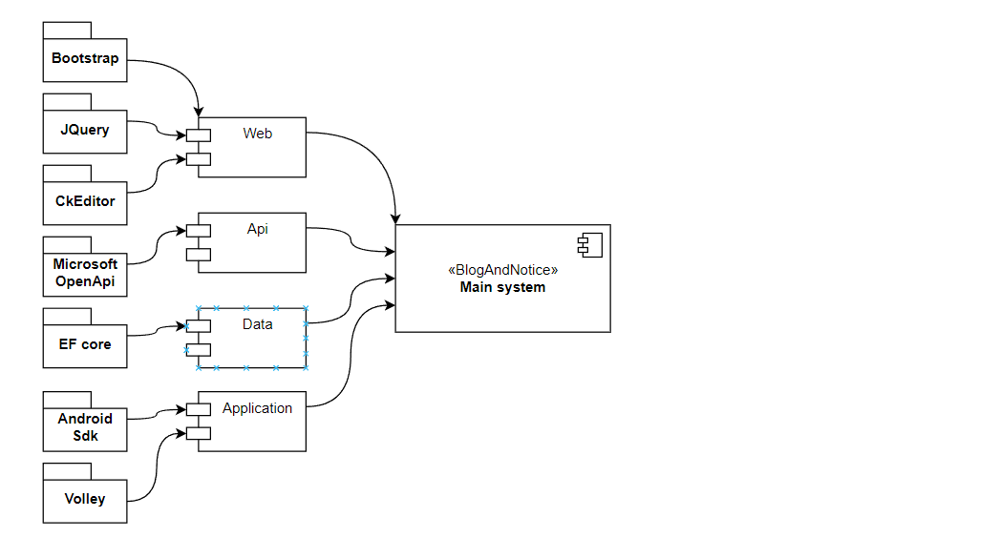

Figure 3 Component Diagram of MMC Blog and Notice System

### 3.2.3 Deployment Diagram

### Deployment

Figure 4 Deployment Diagram of MMC Blog and Notice System

### 3.2.4 Class Diagram

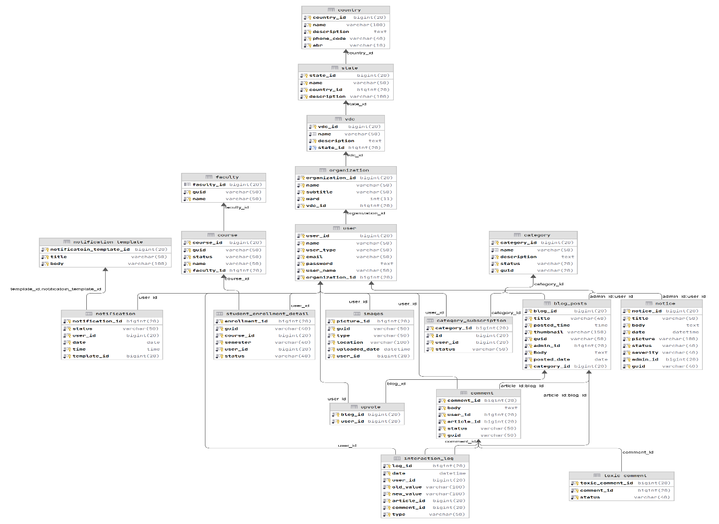

Figure 5 Class Diagram of MMC Blog and Notice System

## 3.3 Algorithm

In our project “MMC Blog and Notice System” we used classification algorithm for predicting appropriation of comments. We are using eager learner classification algorithm for studying the classes and objects of our project. This algorithm is based on a training dataset before receiving a test dataset. The algorithm is executed while submitting the comment. When someone try to comment down anything. At that time our algorithm checks whether that comment is appropriate or not.

# Implementation and Testing

## 4.1 Tools Used

**Front End Tools:**

Front end of this application is designed using ASP.NET Core HTML, CSS, JavaScript, JQuery and Bootstrap Framework. Utilizing the most popular combination of web technologies to develop the MMC Blog and Notice System for users, ASP.NET Core is a cross-platform, high performance, open-source framework for building the system.

Bootstrap is a framework to help us to design websites faster and easier. It includes HTML and CSS based design templates for typography, forms, buttons, tables, navigation, models etc. It also supports for JavaScript plugins.

**Back End Tools:**

The MYSQL storage backend is used in this system. The MYSQL storage backend supports high availability and it is easy to use. Language: C#

Framework: .Net Core, Entity Framework

**Testing Tools:**

The project uses unit testing in both web application and android studio. We aimed to cover most of our project with tests to ensure a reliable software development. The tests have produced a good result in overall software development by helping identify bugs quickly.

Packages used: Xunit (Dotnet), NUnit(Java)

## 4.2 Testing

We are using nugget packages: dotnet-test and XUnit for unit testing. We conducted tests on independent modules and passed all of the tests.

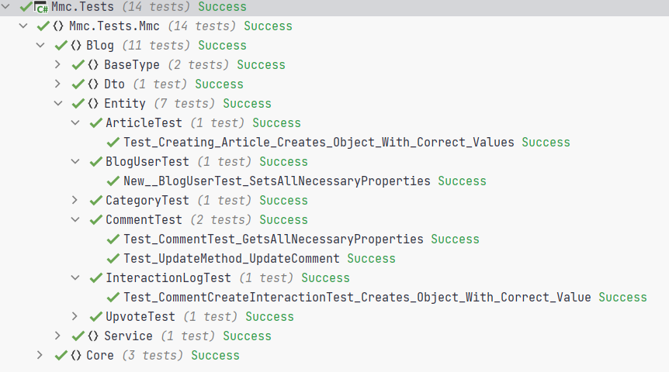

# Conclusion and Learning Outcomes

## 5.1 Conclusion

The Project in Mechi Multiple Campus is an opportunity to develop and enhance technical knowledge for the growth of a career. The real-world implementation and challenges are known and the technical implementations are no more jargons to those who utilize the internship period as a good platform and opportunity.

The project at Mechi Multiple Campus has been a wonderful platform to enhance the skills related to time management, working in a team, meetings and feedback from each members of the organization who has even helped to improve the communication skills. Due to the current pandemic situation, the internship has provided a new experience to work with the team from every corner of the world. The knowledge on development sector as per the context of modern technology on the uses on development fields creating websites as well as mobile applications are the aspects of improvement from the internship program. The developed system can provide basic information regarding the organization which generates more useful methods on the basis of giving the newly updates information provided by the organization.

## 5.2 Learning Outcomes

The success of the system is based on the overall adaptation of the institution. The project can be useful for any institution which requires to communicate with its students frequently. The product is useful in sense that it removes the need to students having to constantly check for new notices. The implementation of the system will save troubles for both campus management and the users. The system is supposed to:

1. Allow campus staffs to login
2. Allow logged in users to post notices
3. Display notification on application user’s devices as soon as a notice is posted
4. Allows logged in users to post blogs
5. Allow web users to post articles in the blog

# 

**References**

[1] – Cally Guerina, Susan Carterb & Claire Aitchisonc

[2] – Hashem A. Alsamadanil, l Umm Al-Qura University

[3] – Eddy K.M Chong* Visual and Performing Arts Academic group, Singapore